BLENDER BASIC OPERATIONS

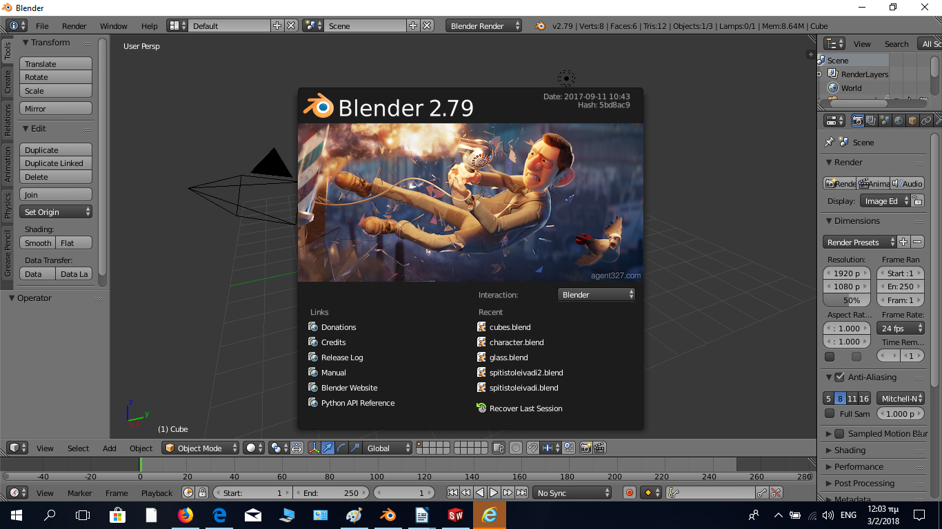

Course in 3D Printing

CodeCreate Program

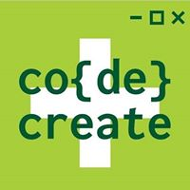
Πίνακας περιεχομένων
Introduction 3
3D software 3
BLENDER 3
Βasic operations 4
Navigation 4
Three button mouse navigation 4
Rotation 5
Selection 5
Objects transformation 5
Exercise 6
Views 7
Numberpad views 7
Project 8
Create a simple Human Figure 8

Introduction

Blender is a professional, free and open source 3D computer graphics software toolset used for creating animated films, visual effects, art, 3D printed models, interactive 3D applications and video games. Blender's features include 3D modeling, UV unwrapping, texturing, raster graphics editing, rigging and skinning, fluid and smoke simulation, particle simulation, soft body simulation, sculpting, animating, match moving, camera tracking, rendering, motion graphics, video editing and compositing. It also features an integrated game engine. (source wikipedia)

3D software

3D software is used to create a virtual representation of something even if it does not exist in the real world.
Following is a list of notable software, computer programs used for developing a mathematical representation of any three-dimensional surface of objects, also called 3D modeling
List of 3D software.

The three basic phases of a 3D computer graphics applications are:
- 3D modeling – the process of forming a computer model of an object's shape
- Layout and animation – the placement and movement of objects within a scene
- 3D rendering – the computer calculations that, based on light placement, surface types, and other qualities, generate the image

BLENDER

Blender is only one of many 3D graphics applications. It can be used to model, sculpt, texture, animate, camera track, render, and composite awesome looking graphics from start to finish
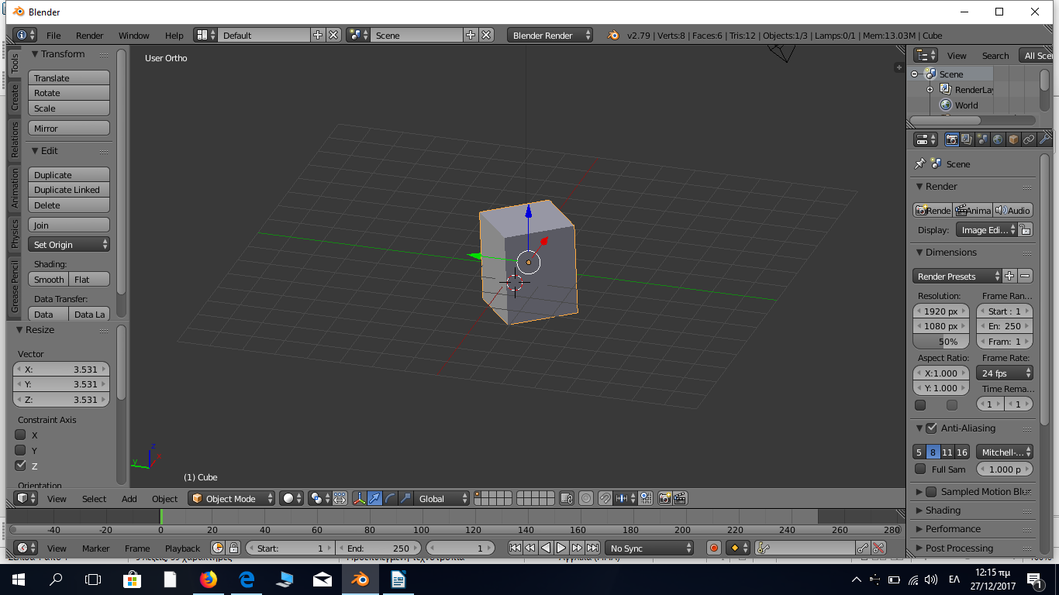

Version v2.79

Blender’s basic screen, version 2.79

Βasic operations

Navigation

The three main navigation controls:

- Zoom: Scroll wheel up or down
- Orbit: Hold down the middle mouse button (scroll wheel) and drag
- Pan: Hold down SHIFT, then click and drag middle mouse button

Three button mouse navigation

If you are using a three button mouse the functions can change:

- Go to the header menu and click on:File →User Preferences
- Go to the Input tab.
- On the left under “Mouse”, check the box Emulate 3 Button Mouse, see figure below.
- To save this as default, click on Save User Settings at the bottom, and
- Exit the window

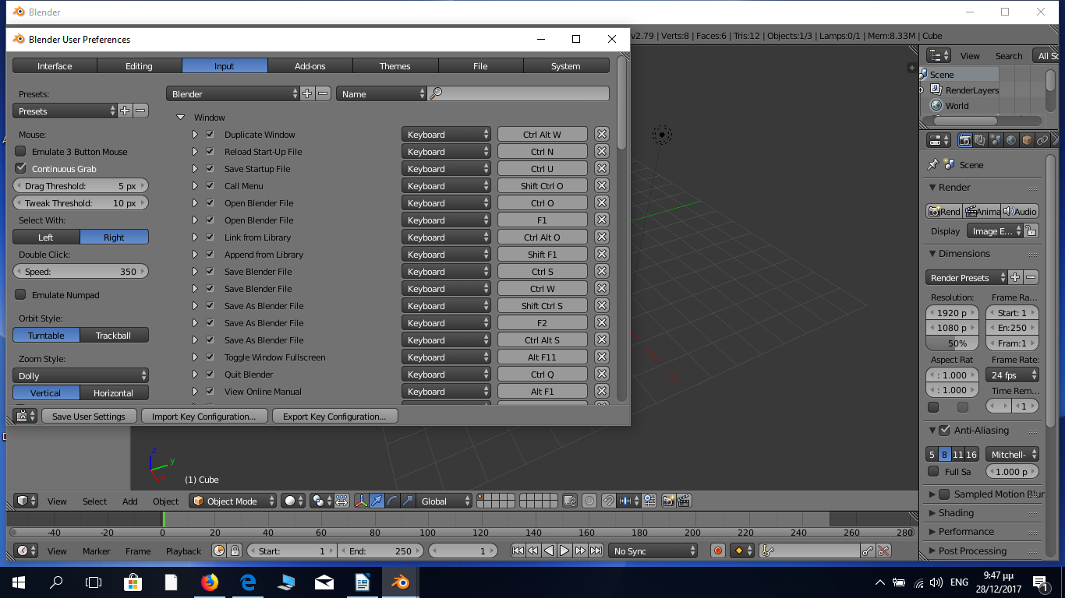
Change functions in a three button mouse
Emulate 3 Button Mouse
Save User Settings

New controls to navigate:

- Zoom: CTRL+ALT+LMB
- Orbit: ALT+LMB
- Pan: SHIFT+ALT+LMB

Rotation

Use the number pad to rotate around the view:

- Top: 7
- Front: 1
- Right: 3

To rotate from the opposite direction, press CTRL in conjunction. Example:
- bottom view: CTRL+7

To view from the local direction, add the key SHIFT. Example
- local top view is SHIFT+7

You can combine these together! Example:
- local bottom view is CTRL+SHIFT+7

Selection

- right click to select an object
The object you select will be highlighted in bright orange. Practice selecting by switching between the objects on your screen.

- Shift +right click to select multiple objects
- right click to one of them to deselect
- CTRL+LMB marquee select
- b+LMB, box Select
- To select all objects, press the hotkey “a”. To deselect all objects, press “a” again
- ALT+RMB to bring up a selection menu for everything under your mouse

Objects transformation

The three main ways to transform objects in blender and other 3D program is
- translation that means “move” or “grab”,
- rotation and
- scaling

One way to transform an object is by using the three arrows that point in three different directions
(manipulator handles)

The red arrow points towards the X axis, the green arrow towards the Y axis, and the blue
arrow toward the Z axis. Also, there is a little compass in the bottom left corner of the 3D view in case you need a reminder.

- Click and drag on one of the colored arrows to move the object along that axis.
- Dragging from the white circle inside the arrows will move the object in relation to your view.

At the bottom of the 3D view, you will see five buttons that control the manipulator. From left to right: toggle on/off, translate, rotate, scale, and orientation.

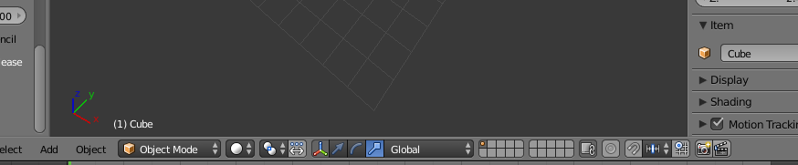
Manipulator Buttons
toggle on/off,
translate,
rotate, scale, and orientation

The first button that looks like the three axes will toggle the manipulator on and off

- The second arrow-shaped button turns on the translate handles, and is selected by default
- The curve-shaped button will switch the handles to rotation handles, and
- The stick-with-a-square-on-it-shaped button will switch to the scale handles.
- SHIFT+click these buttons to use multiple handles at the same time

You can manipulate an object using

- “g” to grab,
- “r” to rotate, and
- “s” to scale.

You can constrain the transformation to an axis by pressing “x”, “y”, or “z” during the transformation. To constrain to two axes, press SHIFT+ whichever axis you would like to leave out. Left click to confirm

Exercise

1. Move the cube along the ground without it moving up or down, press g+SHIFT+z to move it in any direction except the Z.
2. Rotate the cube along the ground without it moving up or down, press r+SHIFT+z to rotate it in any direction except the Z.
3. See what happens if you keep pressing SHIFT.

CTRL + z ---→ UNDO

Views

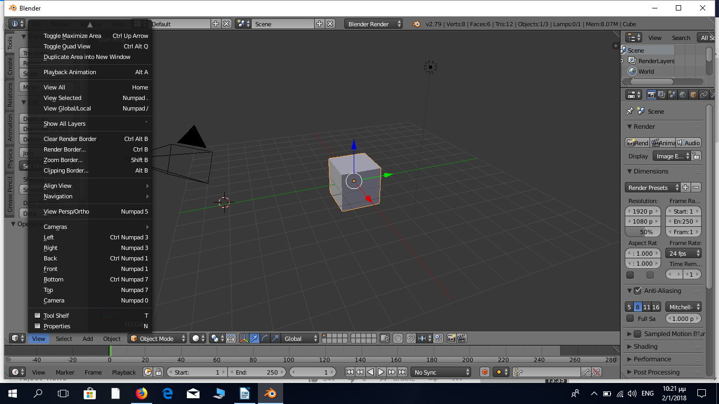
Click on View to select between all available views

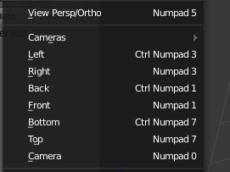
Numberpad views

Perspective/ Orthographic Numperpad 5
Left Ctrl+ Numpad 3
Right Numpad 3
Back Ctrl+ Numpad 1
Front Numpad 1
Bottom Ctrl+ Numpad 7
Top Numpad 7
Camera Numpad 0

Project

Create a simple Human Figure

Step 1 | Step 2
Delete the cube | Shift + a → insert a UV Sphere
 | 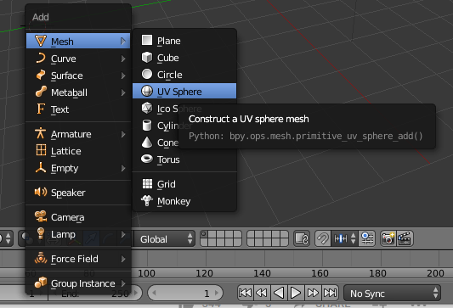
Step 3 | Step 4
Click “g” to move the sphere to the right position | Shift + a → insert a Cylinder
 | 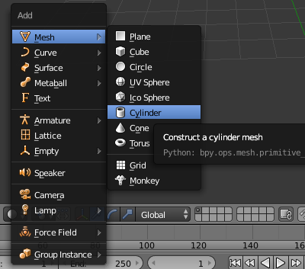
Step 5
Space, write cone-→ add cone
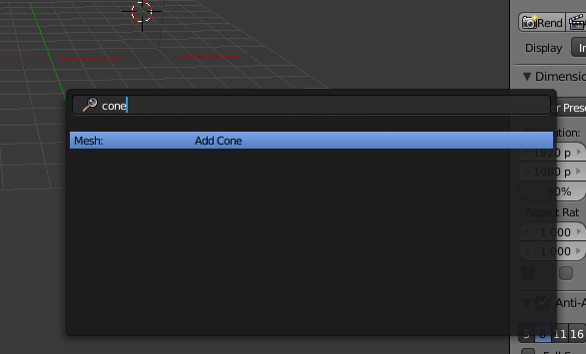

Step 6 | Step 7
Shift + z to decrease the size of the cylinder | Shift + “d” to duplicate the cylinder
 | 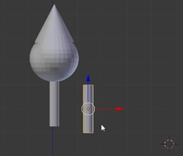
Step 8 | Step 9
Shift + “d” to duplicate the cylinders | Bring pieces together
 | 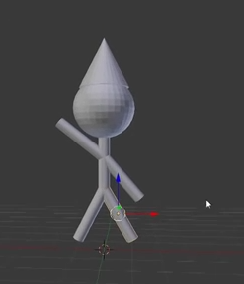
Step 10 | Step 11
Shift + a → insert a plane, | Increase plane and put the figure on the plane
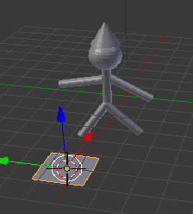 | 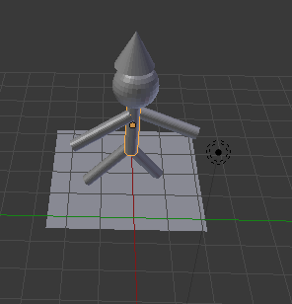
Step 12 | Step 13
Shift + a → insert text | Move text like in the image below
 | 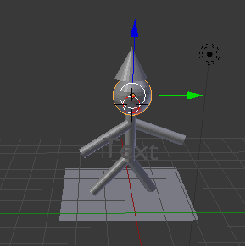
Step 14 | Step 15
Save your work | Export it to an .stl file
 | 

