3D Printing Materials

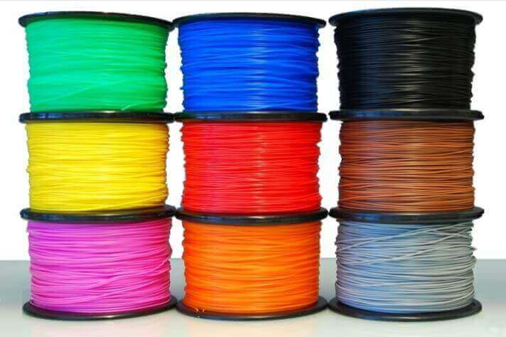

Course in 3D Printing

CodeCreate Program


Πίνακας περιεχομένων
3D Printing Materials 3
Introduction 3
NYLON: (Polyamide) 3
PLA (Polylactic Acid) 4
ABS: (Home printers) 4
Full Color Sandstone 6
Nylon Powder 6
High Resolution SLA 6
Flexible 8
Polycarbonate 8
Z-Ultrat 9
Polymax 9
Wood PLA 10
Metal PLA 10
RESIN: (Multiple options) 12
STAINLESS STEEL 12
GOLD & SILVER 12
TITANIUM 14
CERAMIC 14
GYPSUM 14
Z-GLASS 15
Z-HIPS 15
Glow in the Dark PLA 15

3D Printing Materials

Introduction

There are many materials you can choose from when it comes to 3D printing that it’s often tough to decide on the right one. Simple PLA (Polylactic Acid) and its derivatives is a popular general-purpose 3D print thread.

NYLON: (Polyamide)

Properties | Use
- Also called White, strong & flexible / Durable plastic / White plastic  - Strong and flexible plastic  - 1mm minimum wall thickness  - Naturally white, but you can get it colored  - About 10 layers per 1mm  - Made from powder  - Alumide = Polyamide + Aluminum  - Interlocking, moving parts possible (chain)  This material offers flexibility and great durability, while it is extremely lightweight. It is therefore an excellent choice for printing objects such as tools, sprockets, prostheses or prototype functional models. | 

PLA (Polylactic Acid)

Properties | Use
PLA (Polylactic Acid) is a popular general-purpose 3D print thread. It is produced from renewable sources such as sugar beet, soybean, etc. and is ecological and safe. It is used in all types of models and because of very low shrinkage coefficient it exhibits little distortion even in large objects. Due to low print and easy cooling temperatures, it has an advantage in models with fine details and sharp edges. Its surface is relatively glossy and can be normally treated externally. It is tougher than ABS but brighter. | 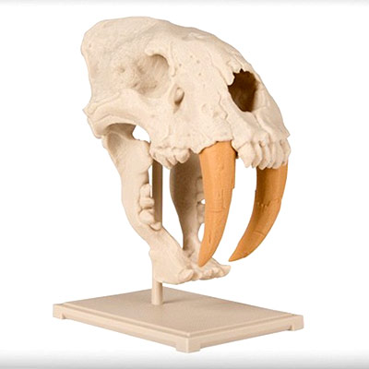

ABS: (Home printers)

Properties | Use
- Strong plastic like legos are  - Made from spaghetti like filament  - Many color options  - About 3 layers per 1mm  - 1mm minimum wall thickness  ABS (Acrylonitrile Butadiene Styrene) is one of the most popular 3D print materials along with the PLA. ABS is more flexible and resistant to impact, it also has a higher melting point and longer life. Its texture is more matte than PLA and can be treated, rubbed and painted. It is also soluble in acetone, which helps us to seal prints together or to smooth them out. It is suitable for all types of models with only a limitation of the very large objects which due to shrinkage may be distorted | 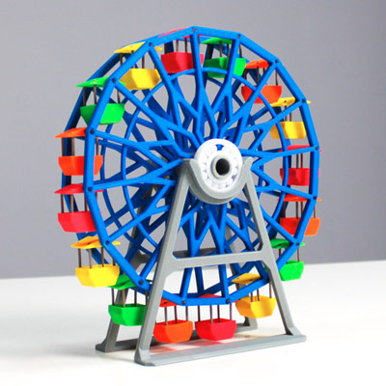

Full Color Sandstone

Properties | Use
Printing in gypsum-based powder, full color. It is the only technology with so good finishing and color rendering. The only choice for surrealistic printing, ideal for prototypes, architectural models, but also for color rendering of scans and / or human figures. | 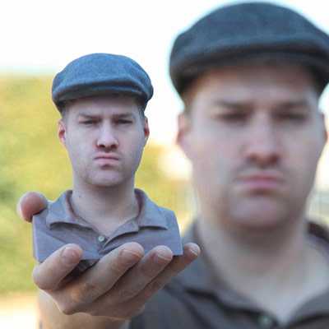

Nylon Powder

Properties | Use
Nylon powder printing has the advantage of large-dimensional precision and the ability to deliver any geometry without restrictions and the need for brackets. It gives absolute freedom in design and is used in all types of models, functional, architectural etc but mainly in prototypes | 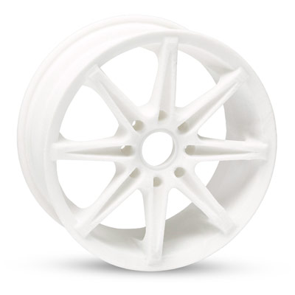

High Resolution SLA

Properties | Use
Ultra-high resolution printing on liquid photopolymerizable resin. It is the ideal method of printing for miniatures and other small objects that have very fine details. | 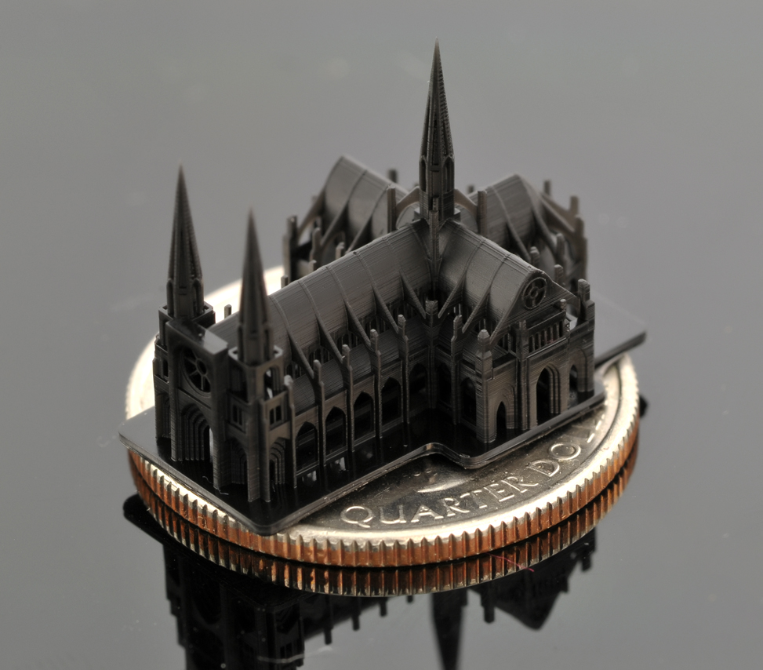

Flexible

Properties | Use
Elastic and very strong TPE elastomer for models that we want to have elasticity, temperature resistance, UV exposure and chemicals. Very elastic and strong, withstands chemical exposure and temperature. It offers a very good fit between the layers and the texture is really like rubber. | 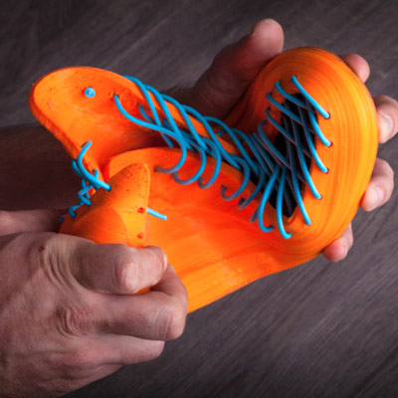

Polycarbonate

Properties | Use
Specially designed polycarbonate consumables that offer superior print quality, excellent mechanical strength and temperature resistance over other 3D printing materials. It is the material of choice for models that are of interest to us, such as spare parts, modeling, drones etc | 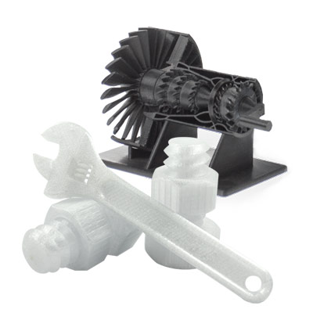

Z-Ultrat

Properties | Use
A composite thermoplastic that is a more sophisticated version of ABS with impurities from other polymers (Polycarbonate etc) that give it hardness and resistance to deformation. It is the most suitable material for printing functional mechanical prototypes, components, and models that we wish to have increased mechanical strengths. It has a relatively glossy finish, ideal layer bonding and excellent precision. | 

Polymax

Properties | Use
It has up to 9 times more impact strength than PLA and 20% greater than ABS and is used when we want to produce PLA-based models but also have excellent mechanical strengths. | 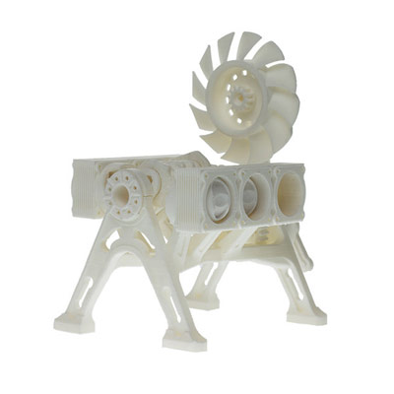

Wood PLA

Properties | Use
Disposable with 30% real wood shavings. The result is impressive with a relatively wild finish and a smell that really resembles wood! Very useful for objects that we want to escape from the plastic look of other 3D printing materials and of course for prototypes that need wood texture. | 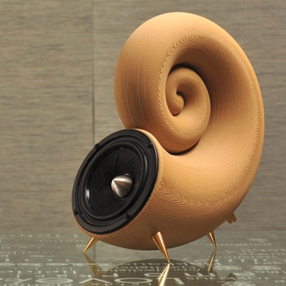

Metal PLA

Properties | Use
Hybrid metal casting for artistic use in metal-like models. It comes in different types depending on the type of metal contained in the yarn. The most popular are bronze and copper. After printing, the models have a matte look and with the proper processing the metal filings are highlighted and the final result looks like real metal! | 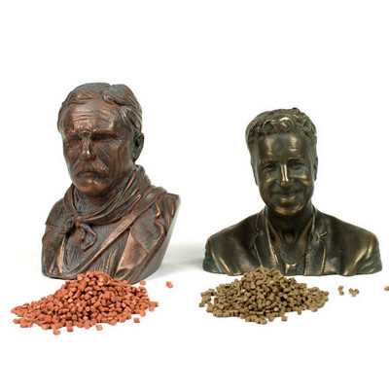

RESIN: (Multiple options)

Properties | Use
- Also called White-, Black-, Transparent detail / White detail resin / High detail-, Transparent-, Paintable Resin  - Rigid and a bit delicate  - Liquid Photopolymer cured with UV light  - White, black & transparent most typical colors  - About 10 layers per 1mm  - 1mm minimum wall thickness | 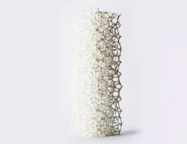

STAINLESS STEEL

Properties | Use
- Very strong material  - Made with multiple steps or from powder directly  - Coloring options like gold and bronze plating  - About 6 layers per 1mm  - 3mm minimum wall thickness | 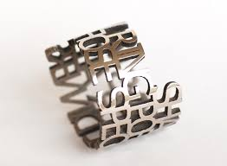

GOLD & SILVER

Properties | Use
- Strong materials  - Made from wax and then casted  - About 10 layers per 1mm  - 0.5mm minimum wall thickness | 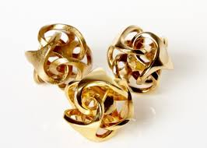

TITANIUM

Properties | Use
- Strongest material  - Direct metal laser sintering  - About 30 layers per 1mm  - 0.2mm minimum wall thickness | 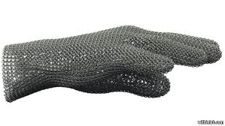

CERAMIC

Properties | Use
- Rigid & delicate  - First ceramic is printed then surface is glazed  - Ceramic white, glaze typically white  - About 6 layers per 1mm  - 3mm minimum wall thickness | 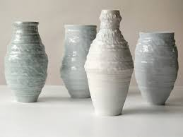

GYPSUM

Properties | Use
- Also called Sandstone / Rainbow ceramics / Multicolor  - Rigid & delicateMade from powder  - Naturally white, but you can get it with colors  - About 10 layers per 1mm  - 2mm minimum wall thickness | 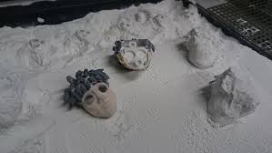

Z-GLASS

Properties | Use
It is a translucent thermoplastic with great light transmission and excellent mechanical properties, reduced warping, abrasion resistance, tensile strength and high temperatures. It also has high chemical resistance to acids, salts and alkaline compounds. | 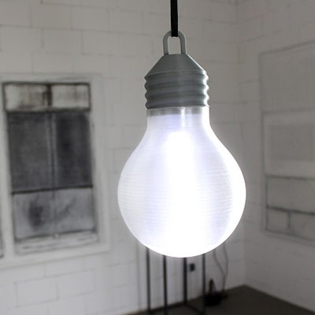

Z-HIPS

Properties | Use
Z-HIPS (high impact polystyrene) is a very durable consumable with a very low shrinkage factor and therefore minimal warping. It is not extremely hard and as a result it is not brittle and withstands pressure and tensile forces. Extremely useful for large objects with difficult surfaces but also for architectural models. | 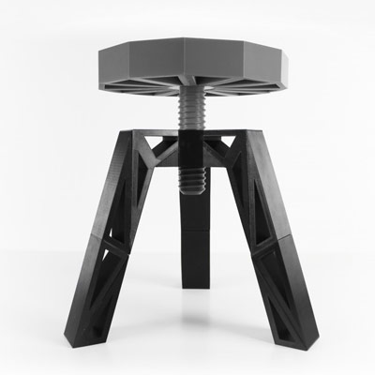

Glow in the Dark PLA

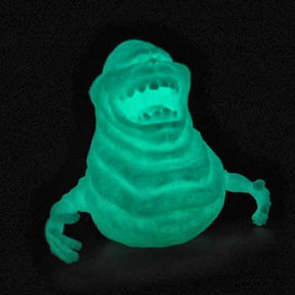  Properties | Use
A very interesting consumable based on PLA but with the ability to accumulate light from natural or artificial sources and then to radiate it. Useful for very impressive decorative or other models that we want to shine in the dark!

