Project
Create and Print two cubes to snap each other

Step 1

Create 3 cubes 1.8x1.8x1.8 and add them on the top of the cube

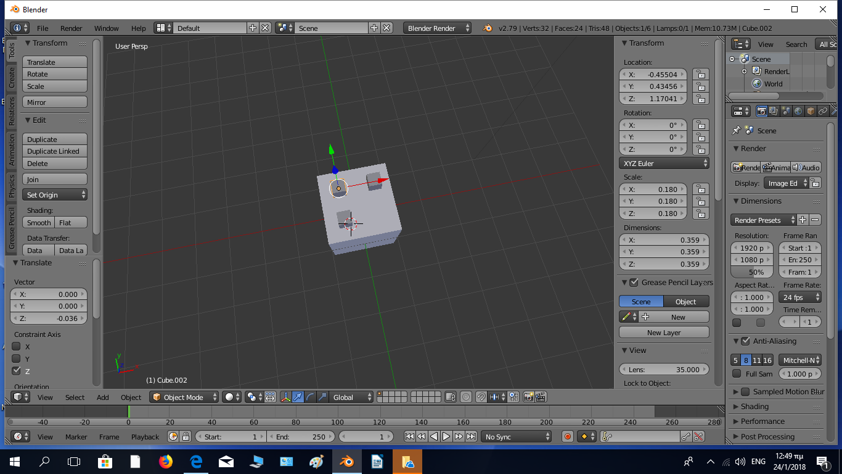
Step 2

Add the “boolean” modifier, select “union” for all the 3 small cubes to unify the 4 cubes into one subject

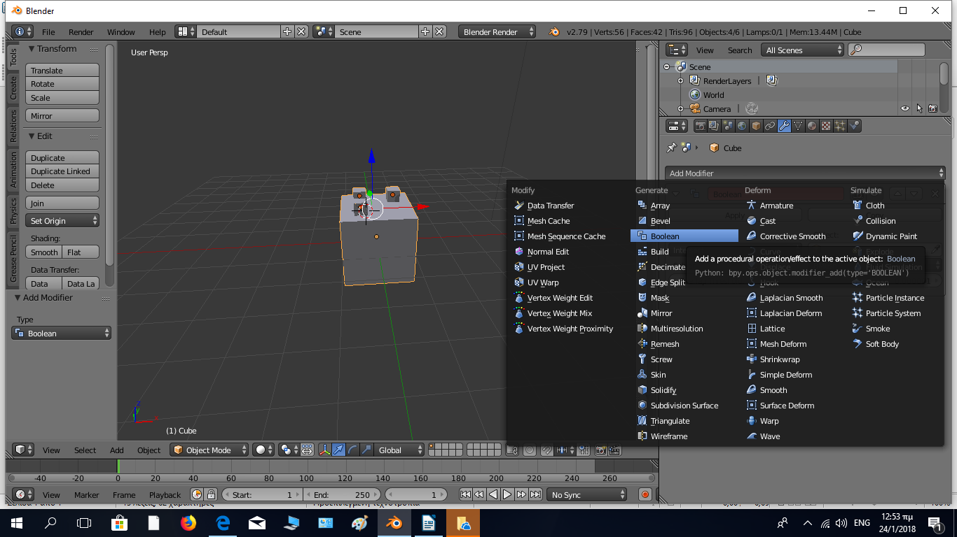
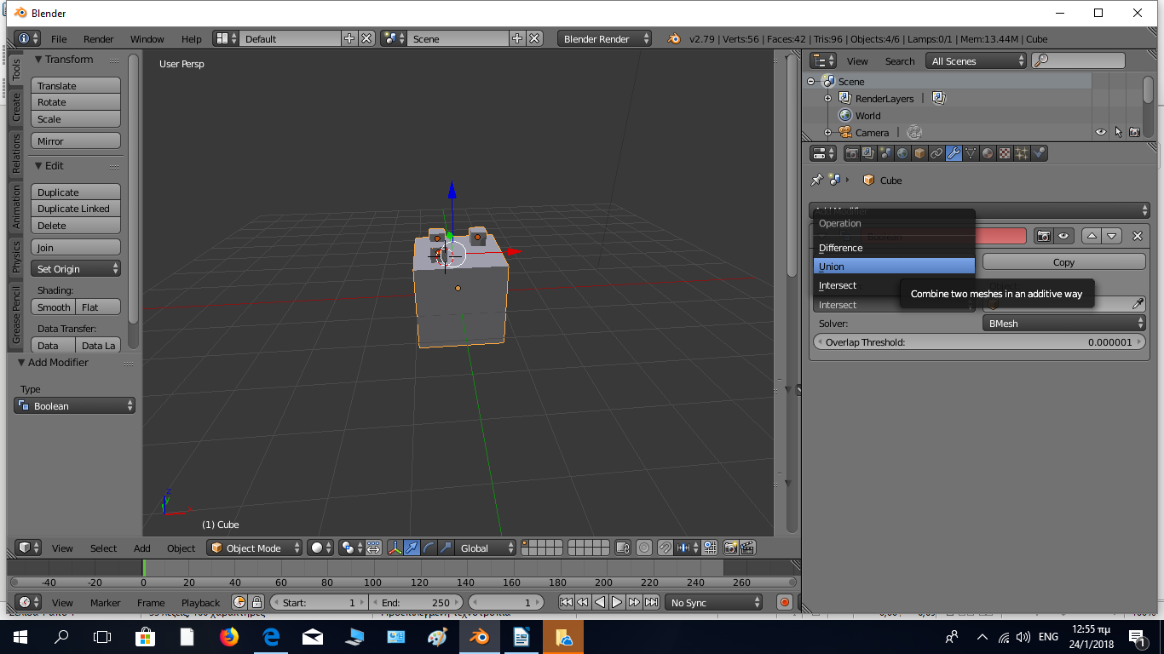

Step 3

Insert a 4th cube and place it on the top of the first cube covering the 3 small cubes

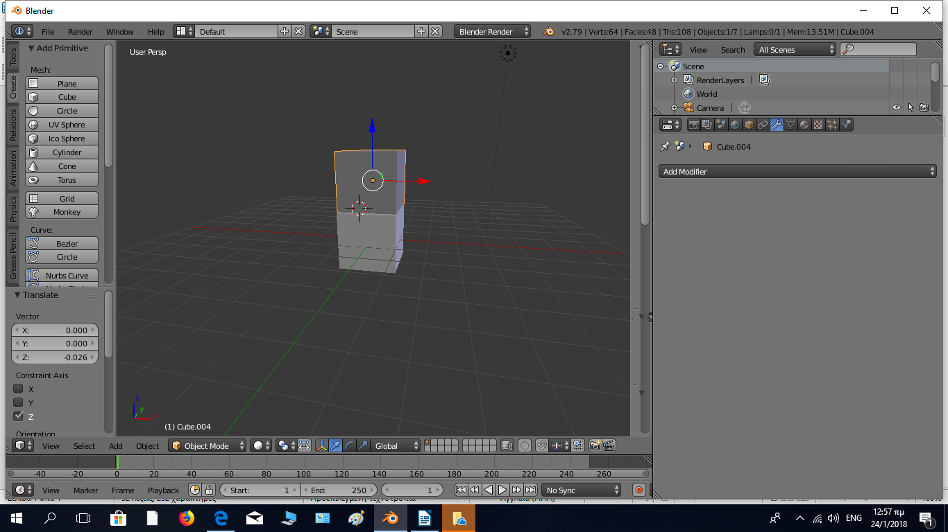
Step 4

Apply the “boolean” modifier and select difference to create 3 cube wholes to the opposite face of the 4th cube similar to the 3 identical cubes.

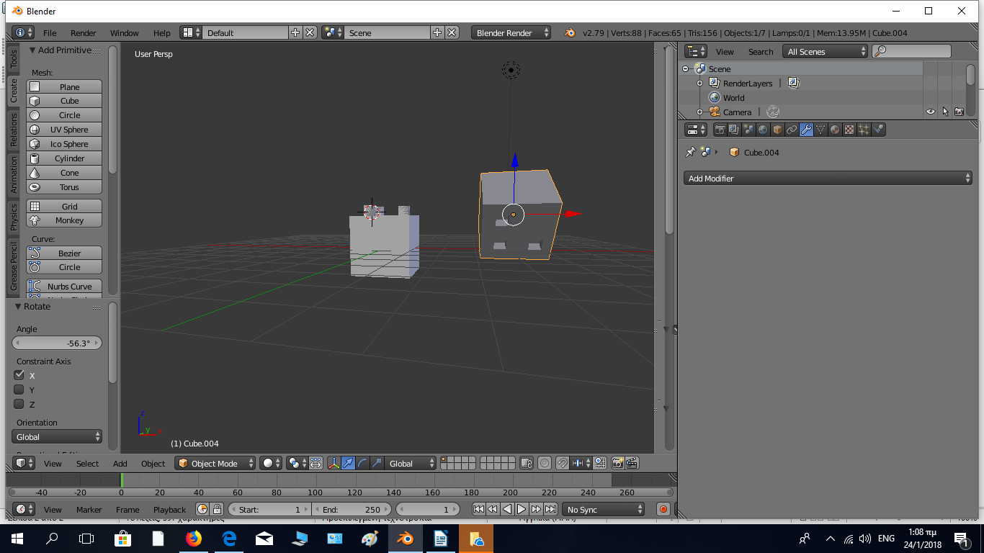

Step 5

Select the 4th cube turn to edit mode, select the top acne and move it up to the bottom parallel acme

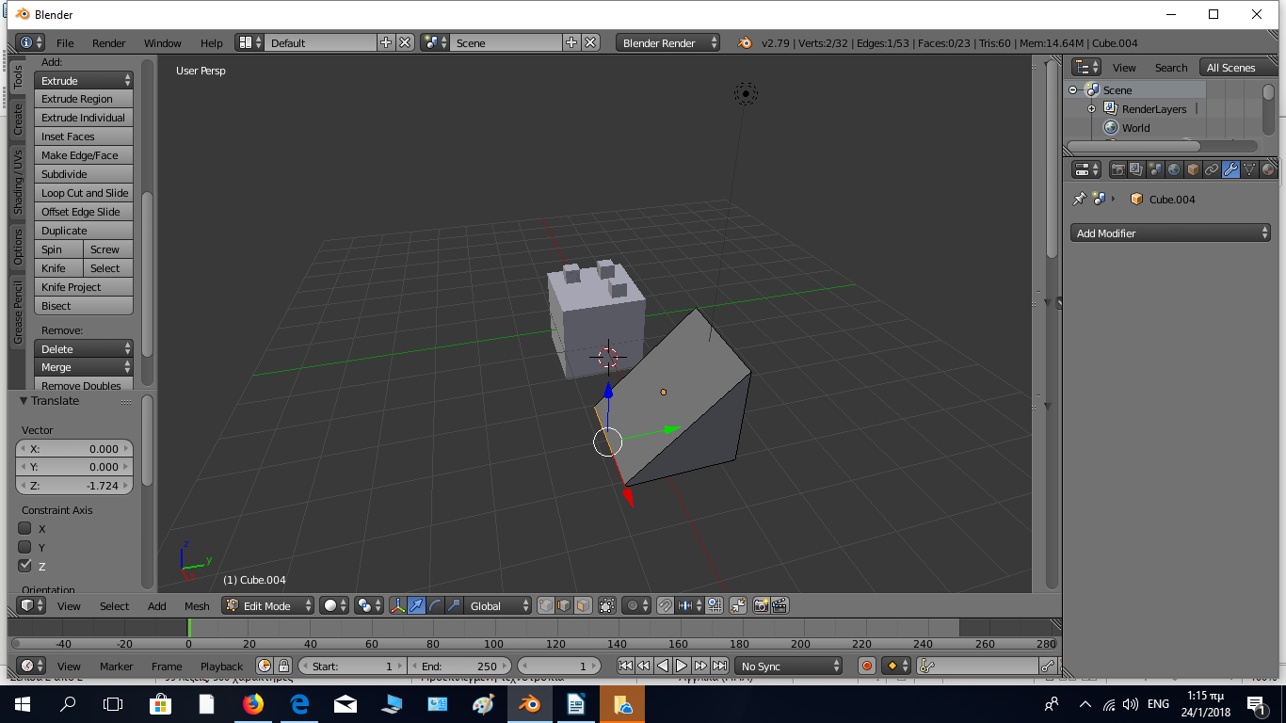
Step 6

Save your file and export it as an .stl file

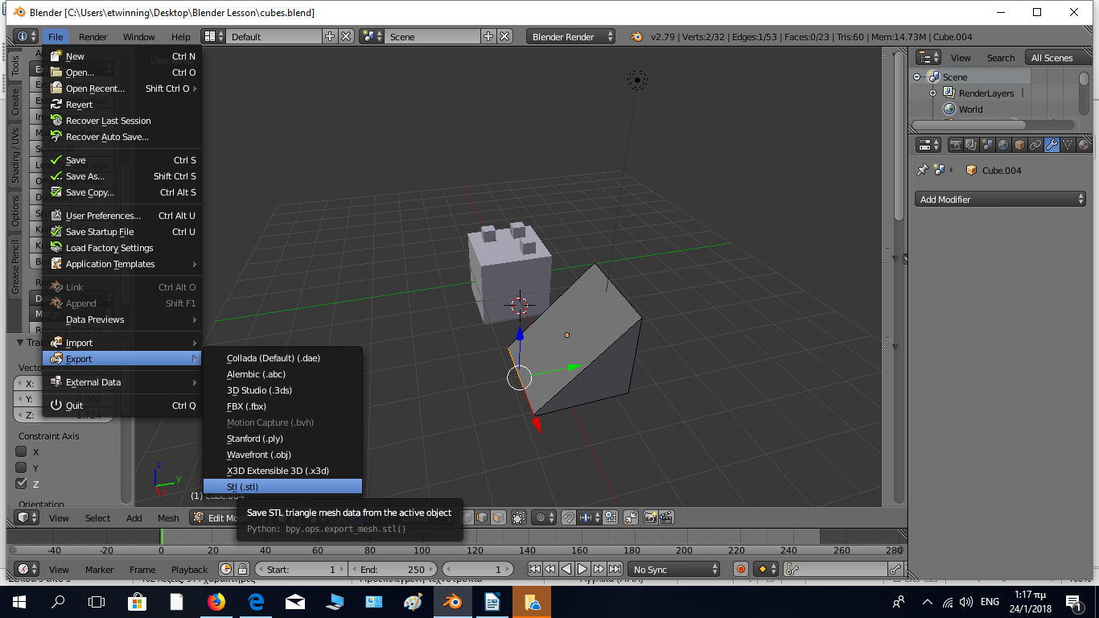
Step 7

Load your file into Cura, define the proper dimensions and print it out.

